Software Requirements Specification

for

Project ΜusicBox.Net
Requirements for Version 1.7.5.5
Prepared by Katerina Fotiou
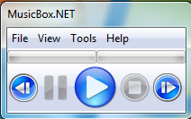
Software Engineering, AUTH

Table of Contents

Revision History 3

1. Introduction 6
1.1 Purpose 6
1.2 Document Conventions 7
1.3 Intended Audience and Reading Suggestions 7
1.4 Project Scope 7
1.5 References 8
2. Overall Description 9
2.1 Product Perspective 9
2.2 Product Features 11
2.3 User Classes and Characteristics 12
2.4 Operating Environment 12
2.5 Design and Implementation Constraints 12
2.6 User Documentation 12
2.7 Assumptions and Dependencies 12
3. System Features 13
3.1 File menu 13
3.2 View menu 15
3.3 Tools menu 19
3.4 Help menu 26
3.5 Buttons 28
3.6 Keyboards 29
4. External Interface Requirements 30
4.1 User Interfaces 30
4.2 Hardware Interfaces 31
4.3 Software Interfaces 31
4.4 Communications Interfaces 31
5 Other Nonfunctional Requirements 31
5.1 Performance Requirements 31
5.2 Safety Requirements 31
5.3 Security Requirements 31
5.4 Software Quality Attributes 31

Revision History

Name | Date | Reason For Changes | Version
MusicBox.Net |  | -Fixed Forms Display  -Added Flower Style  -Downloads For Program And Source Code Shifted To SourceForge  -Added new style for the Playlist Tool instead of the ugly and dull buttons and color | V1.5.0.0
MusicBox.Net |  | -Added chiptunes high / low support  -Added chiptunes visualization support  -Added filter in open file dialog for chiptunes(.xm, .mod, .mtm, .mo3, etc)  -chiptunes now play as an incomplete Mp3 file(playable but unable to draw wave graphs or detect full length)  -Fixed chiptunes filter(previous versions play .xm only)  -Using BASS instead of BASSmod for chiptunes support  -Fixed visualization stuck on the previous song. | V1.5.5.0
MusicBox.Net |  | -Added addon support  -Added Music Info to get the information of the audio file(eg : Title, Artist, Album Artist, etc)  -Added self error handler(self made message box)  -Fixed installer shortcut error  -Fixed install directory  -Fixed wave graph stuck on the previous song | V1.5.5.5
MusicBox.Net |  | -Added lyrics support(automatically find .LRC files under /Lyrics)  -Added buttons over, down, normal images  -Added icons under menu  -Added shortcuts  -Added Tracker(tracks and lets you set the current position, also lets you set the volume)  -Organized about page  -Enhanced about page(you know it when you started to hear sounds coming from it)  -Fixed K in about page | V1.6.0.0
MusicBox.Net |  | -Fixed a very annoying "stop" button bug  -Fixed "pause" bug  -Fixed chiptunes complete length (now finds the complete length of chiptunes).  -Completely removed "BASSMOD" from the application's root.  -Completely removed "WMP" OCX from the application's root.  -Added multiple selections.  -Playlist now loops.  -Added "Play From URL", also supporting radio stations (.ASX).  -Added "Hide To Tray" feature, which will allow you to hide MusicBox.NET into the tray icon.  -Added three new menu items under "Help"  -Added Skin / Themes feature, MusicBox.NET is now skinnable!  -Added "Donate" page to MusicBox.NET's website.  -Program is now slimmer than the previous stable releases. | V1.6.5.0
 |  | -Fixed playlist loop bug.  -Added Repeat Playlist function.  -Updated BASS version from V2.4.6.4 to V2.4.6.5  -Fixed skinning bug.  -Fixed repeat bug(stops playing after repeating several times)  -Updated about page.  -Added online help doc. | V1.6.5.5
MusicBox.Net | 28-9-2010 | -New tags reader(taglib-sharp.dll)  -Now supports reading album cover.  -14 new visualizations.  -Full screen Visualizations(Press F11)  -Enhanced for Windows 7(taskbar buttons, taskbar progress bar)  -Fixed position tracker.  -Support for more Internet Radio stations format(iTunes /WinAMP : .PLS|WMP : .ASX|Realplayer : .RAM)  -Support for languages(CTRL + SHIFT + L)  -Now with magnetic function(just like WinAMP)  -Cursor hides when Visualization is full screen.  -Autoload BASS addons on startup.  -Autoadd BASS addons filter on startup.  -Visualizes Aero  -Added mixer for DX8 FX, 128khz, etc.  -Can handle arguments without the need of ArgsHandler.  -Add file to playlist if application is already running.  -Able to associate all supported file formats to application via registry (requires admin privillege in Vista / 7).  -Added tags editor.  -Added console application which acts like a Windows' Command Prompt(CMD) for MusicBox.NET | V1.7.0.0
MusicBox.Net | 28-11-2010 | -Added global hotkeys  -Bug Fixes  Added scroll-bar to console to allow users to scroll down / up. | V1.7.5.0
MusicBox.Net |  | -Fixed a bug where the user presses ALT + F4 (on a sub form) and the program goes not-responding.  -Added a feature for the visualization(Left = Next, Right = Previous)  -Added function to unassociate associated file formats.  -Updated all links under "Help"  -Changed Bass addons directory to /addons (put all BASS addons to /addons directory) | V1.7.5.5

Stable Releases:
V1.0.0.0
V1.5.0.0
V1.5.5.0
V1.5.5.5
V1.6.0.0
V1.6.5.0
V1.6.5.5
V1.7.0.0
V1.7.5.0
V1.7.5.5

1. Introduction

  - Purpose
Τhis Software Requirements Specification document has been created for the program MusicBox.net version 1.7.5.5 which is an advanced music player for playing ordinary audio formats and chiptunes.
Musicbox.Net is a free, open source program. Free software is software which may be used, studied, amended and returned without restriction.

Document Conventions

This document is unique. It‘s scope is to describe the requirements of the program MusicBox.Net and the interfaces for it.

The document’s structure is based on:

http://www.processimpact.com/process_assets/srs_template.doc

It also, used page https://sourceforge.net/projects/musicboxdotnet/.

This document has been created after the program MusicBox.Net and it is important to note that future changes to the program should be included in this requirements Specification document, in order to maintain its usefulness. Since the program has already implemented, some parts of this document seem sufficiently with a user guide.

Intended Audience and Reading Suggestions
This document:
- may be used by ordinary users of the program. They can easily understand the features and the operations of MusicBox.Net .They can also be informed of all the possibilities the program provides. Users can get a general image of the program and run it with a better ease and understanding. Users must give particular attention to Chapter 3 and 4, which include the characteristics of the program, to obtain the basic knowledge for its use.
- also, this document could be studied by the program developers, so they have the chance to identify and alter possible points which need improvement. Also, they can fully understand the nature of the program and implement new features. It is recommended to comprehensive study of the document for the full understanding of the program and to avoid errors.
- also, helps project testers understand how MusicBox.Net is supposed to work properly and identify bugs and errors easier.

Project Scope
MusicBox.NET is a windows form music player application. It is build based on the audio library BASS developed by un4seen developments, it supports not just modern day audio formats such as MP3 or WAV but also OGG, WMA, MPC, FLAC and can be expanded by addons. It also supports chiptunes and plays them like a normal audio file. Next Chapters include extensive reference to these capabilities of the program.

References
Website: http://www.musicboxdotnet.sourceforge.net
Project's Home: http://www.sourceforge.net/projects/musicboxdotnet
Blog: http://www.musicboxdotnet.blogspot.com

Readers can find relevant reports and information for the MusicBox.Net in this Website:
http://www.musicboxdotnet.sourceforge.net

They can also learn more about the program in Project’s Home: http://www.sourceforge.net/projects/musicboxdotnet
They can download and see all the previous releases, code, and problems that have been solved.
They can find information about the developers, as well as comments users.
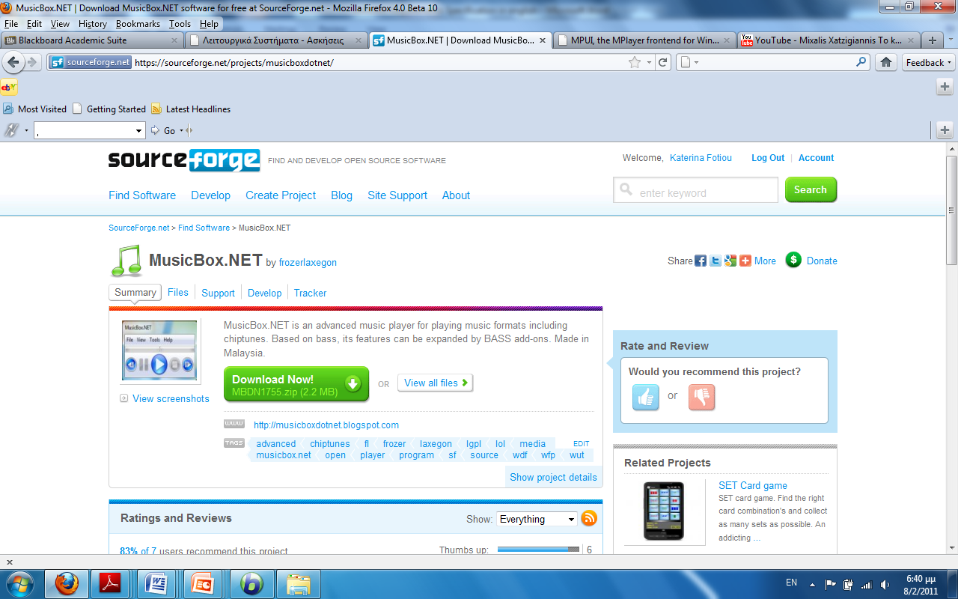

Blog: http://www.musicboxdotnet.blogspot.com
There is full reference for the program, statistical data and relevant video.
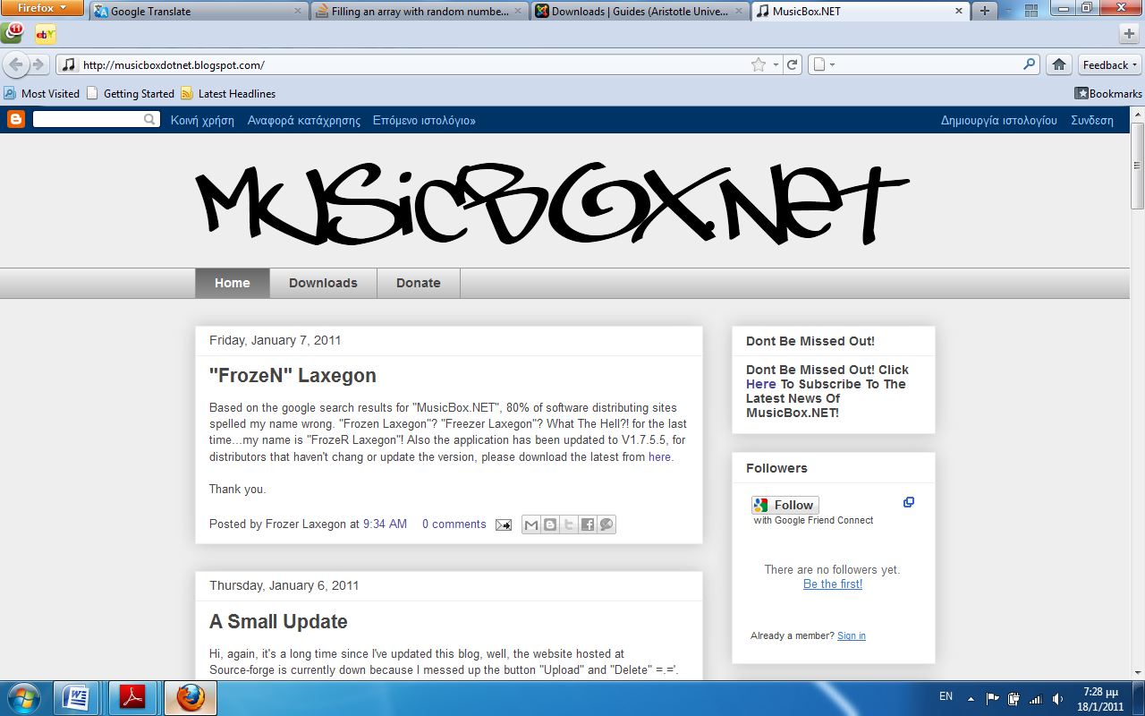
These sites donate any information and documents about this project. Furthermore, they provide discussions with the project’s participants.

Overall Description

2.1 Product Perspective
The MusicBox.Net belongs to music player category. These are the minimum requirements that are needed to run and built MusicBox.NET:
- OS: Windows XP with Service Pack 3 installed.
- .NET Framework: .NET Framework 3.5.
- DirectX: DirectX 3 for audio.
- RAM: 512MB.
- Disk Space: 10MB free space.

Product Features
- Simple GUI.
- Full Support For All Audio Formats.
- Visualizations.
- Load / Save Playlist into ".wpp" files.
- Plays Next / Previous Track On Playlist.
- Two Progressbar shows the high and low point of the playing audio file
- Small File Size (Installer is less than 1 MB).
- GPL Version 3, Open Source.
- Forms sticks together.
- Partial Support for Chiptunes.
- Flower Style Forms (V1.5).
- Skinnable.
- Repeat / Repeat playlist.
- Online Help Doc.
- Custom Progress bars.
- Full Screen Visualizations.
- Support For Album Cover Art.
- Enhanced For Windows 7.
- Magnetic forms just like WinAMP.
- Associate File Formats.
- Autoload BASS addons.
- Open files although the application is already running.
- Supports for languages.
- Uses BASS and BASSMOD as core to decode and output music.
- Output audio clearly on high definition (also depends on your system).
- Add from URL / Folder / File.
- Hide to tray function to replace the "minimize" button.
- Unlimited songs on playlist.
- Uses .LRC lyrics format.
- Tracker to track audio positions and volume.
- Wave graph.
- Visualizes Window's Aero (Windows 7 only).
- Mixer to set DX8 effects on the current playing audio.
- Simple Tags editor to edit title, artist and album.
- Shows left / right audio volume.
- System-wide hotkeys.
- Simple interface.
- Console (CMD) interface.

All these will be analyzed in detail in Chapter 3.

User Classes and Characteristics
The software can be used by the following user categories:
- Simple users that intend to hear a song. These users could be of any age, with no special knowledge. Knowing how to use a computer is an essential.
- Programmers- Software Developers –Open Source project participants of any age that could understand the program’s source code and expand or improve it. Must have knowledge of the programming language that the software is written in, in order to be able to understand exactly what it does and how it does it. Also some experience on programming will most certainly help on extending or improving the project.
This is an Open Source project and anyone who desires to distribute to the project is welcome.

General there is no restriction in user’s categories and everyone using a computer can use this program.

Operating Environment
Programming language:
- Visual Basic

Operating System:
All 32 bit MS Windows:
- Windows 95
- Windows 98
- Windows NT
- Windows 2000
- Windows XP
- Windows 7
- Windows Vista

Design and Implementation Constraints
MusicBox.Net is developed under the GNU General Public License which means that the software is an Open Source project. MusicBox.Net is free software: you can redistribute it and/or modify it under the terms of the GNU General Public License as published by the Free Software Foundation, either version 3 of the License-GNU Library or "Lesser" General Public License version 3.0 (LGPLv3).

For more information on the GNU license visit:
http://www.gnu.org/licenses/licenses.html

  - User Documentation
There is a Help Doc on MusicBox.Net

2.7 Assumptions and Dependencies
No assumptions have been made and no dependencies exist.

3. System Features

The system features and functional requirements are described in detail, to help the reader understand the application better and developers and testers in their future work in MusicBox.Net.

3.1 File Menu

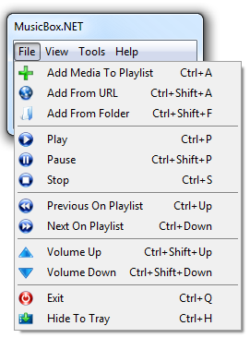
The first choice is File menu which includes the following:

Add Media To Playlist Ctrl+A
With this choice, users can choose a song from the hard disk and add it to the playlist. When a user chooses the file then this will start playing automatically. Users can add file to playlist if application is already running. Users can also activate this choice if they key in CTRL+A on the main window.

Add From URL Ctrl+Shift +A
With this choice a box pops up and users can key in song’s URL so they can download it from a website and add it to the playlist. It is recommended to use a direct link. It also supports internet radio stations that end with a format such as ".asx", ".pls", etc. After doing so click Add From URL. Users can also activate this choice if they press CTRL+Shift+A on the main window.
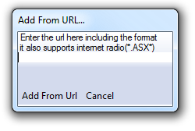

Add From Folder Ctrl+Shilt+F
With this choice users can choose and open a folder containing sound archives. A folder browser pops up, and users navigate to the folder they want to add to the playlist. When users press OK on the folder browser all the files of the folder will add automatically in the playlist. Users can also activate this choice if they key in CTRL+Shilt+F on the main window.

Play Ctrl+P
With this operation the chosen song starts play. If there are not registered records in the playlist when users choose Play, then user has the opportunity to choose song from the disk automatically. Users can also activate this choice if they press CTRL + P on the main window.

Pause Ctrl+Shift+P
This choice interrupts the song and if user chooses Play then song starts playing from the same point. Users can also activate this choice if they key in CTRL+Shift + P on the main window.

Stop Ctrl+S
With this choice the song stops playing. If user chooses the choice Play the file will start to play from the beginning. Users can also activate this choice if they key in CTRL+S on the main window.

Previous on Playlist Ctrl+Up
With this choice the previous song on playlist is chosen automatically and starts play.
Users can also activate this choice if they key in CTRL+Up on the main window.

Next on Playlist Ctrl+Down
With this choice the next song on playlist is chosen automatically and starts play.
Users can also activate this choice if they key in CTRL+Down on the main window.

Volume Up Ctrl+Shift+Up
This choice is increase the sound. User can also activate this choice if they press CTRL+Shift+Up on the main window.

Volume Down Ctrl+Shift+Down
This choice is reduce the sound. Users can also activate this choice if they key in CTRL+Shift+Down on the main window.

Exit Ctrl+Q
With this choice users can close the MusicBox.Net. This choice closes the program. Users can also activate this choice if they key in CTRL+Q on the main window.

Hide To Tray Ctrl+H
This choice is hide the program‘s window into the tray icon but MusicBox.NET is still running. Users can activate this choice if they key in CTRL+H on the main window.

3.2 View Menu

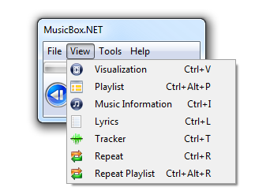
The second option is View menu which includes the following:

Visualization Ctrl+V
The choice is Visualize the sound. A new window appears which gives the user a graph of sound. If users click on it, they can see successively all the visualizations that program offers. With right click goes on next graph while with left click it will return them back. There are fourteen visualizations in the program. Users can also toggle full screen mode on the visualizations by pressing F11 while the visualization window is selected. If users press F11 again will return back to normal. Cursor hides when Visualization is full screen. Users can also activate this choice if they key in CTRL+V.
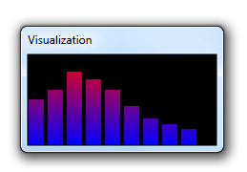
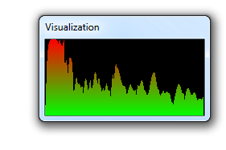

Playlist Ctrl+Alt+P
This choice pops up a new window where displayed songs which are to be played. Users can also activate this choice if they key in CTRL+Alt +P.

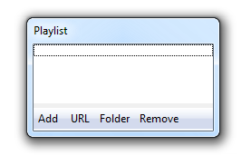

The above box has the following buttons:

Add
With this button users can easily add items to the playlist.

URL
With this button pops up a box that users can key in song’s URL so they can download it from a website and add it to the playlist.

Folder
With this choice, a folder browser should pop up and users can choose the folder they want to add to the playlist. If they press OK all the files of the folder will automatically add in the playlist.

Remove
With this selection, the user can remove any sound archive wants from the playlist. Users can also remove the item if they right click at the selected item in the playlist and select Remove.

Music Information Ctrl+I
With this choice appear two new windows with all the information for the current file sound. Specifically the window album cover art shows the image of the cover of album and the second window shows the following information:
- title
- artist
- album
- album artist
- composer
- track
- type
- year
- comments
Users can also activate this choice if they key in Ctrl+l on the main window.
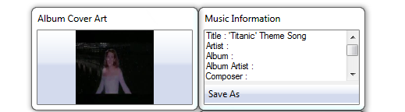
Lyrics Ctrl+L
With this operation users can see the song’s lyrics in a new box. Users must drop lyric files [.lrc] in the folder Lyrics. The lyric files’ name must be exactly the same with song’s name (e.g.: "The Black Parade", "The Black Parade.lrc").
Users can also activate this choice if they key in Ctrl+L on the main window.

Tracker Ctrl+R
With this choice pops up a new box which has two progress bars. The first is the indication progress bar (forward/rewind) and the second is the volume bar (increase/reduce). Users can change the current playing position and the volume.
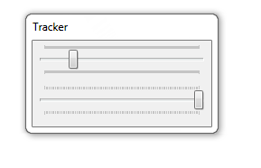
Users can also activate this choice if they key in CTRL+R on the main window.

Repeat Ctrl+R
With this operation users can listen a song repeated. Users can also activate this choice if they key in CTRL+R on the main window.

Repeat Playlist Ctrl+Alt+R
With this operation users can listen the entire playlist repeated. When users choose again this operation, the songs on playlist will not repeated by the end of the playlist. Users can activate this choice if they press CTRL+Alt+R on the main window.

3.3 Tools Menu

The third option is Tools which includes the following:
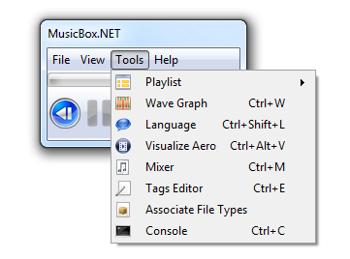

Playlist
Users can save their playlist into a file that they can later load it back up. In this way users don't have to reselect the files they've already selected previously. This selection offers those two choices:
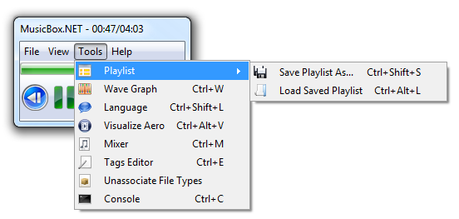
Save Playlist As… Ctrl+Shift+S
With this choice users can save any playlist has created in MusicBox.Net.
Users can activate this choice if they key in Ctrl+Alt+S on the main window.

Load Saved Playlist Ctrl+Alt+L
With this operation a file browser pops up. Users can choose and load up again the already saved playlists. Users can activate this choice if they key in Ctrl+Alt+L on the main window.

Wave Graph Ctrl+W
With this choice appears a new window that includes a wave graph which shows sound’s frequency for the current song. Users can activate this choice if they key in Ctrl+W on the main window.
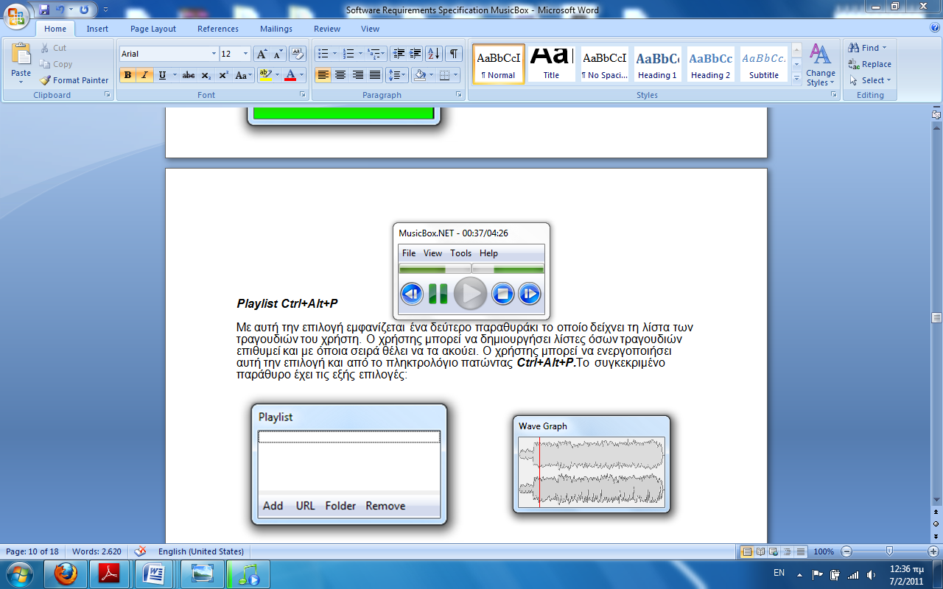

Language Ctrl+Shift+L
With this operation users can install a language.
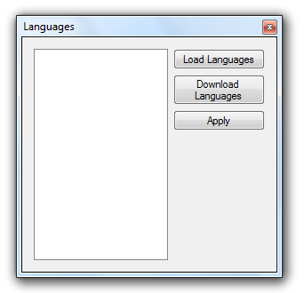
This selection offers those three choices and users can activate this choice if they key in Ctrl+Shift+L.

Download Languages
To install a language, users must first download one. After they will have a language file (e.g.: Chinese Simplified.wpl) they must click Load languages.

With this operation it opens:

https://sourceforge.net/projects/musicboxdotnet/files/Languages/

Users can download English or Chinese languages from there and install it on the MusicBox.Net.

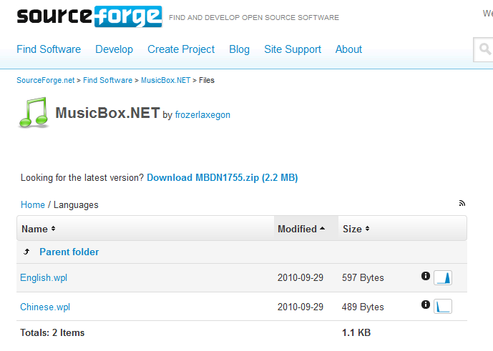

Load Languages
With this choice, users can select the file they downloaded.
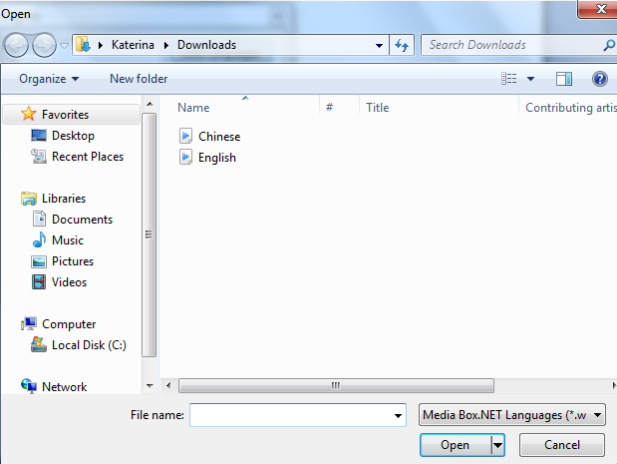

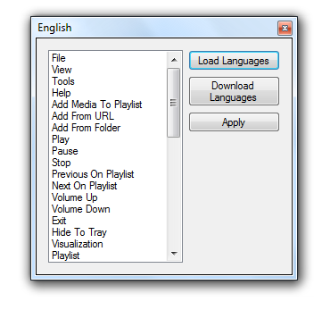

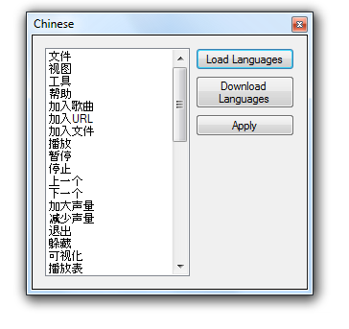
Apply
This choice applies the selected language as the default language of the program.

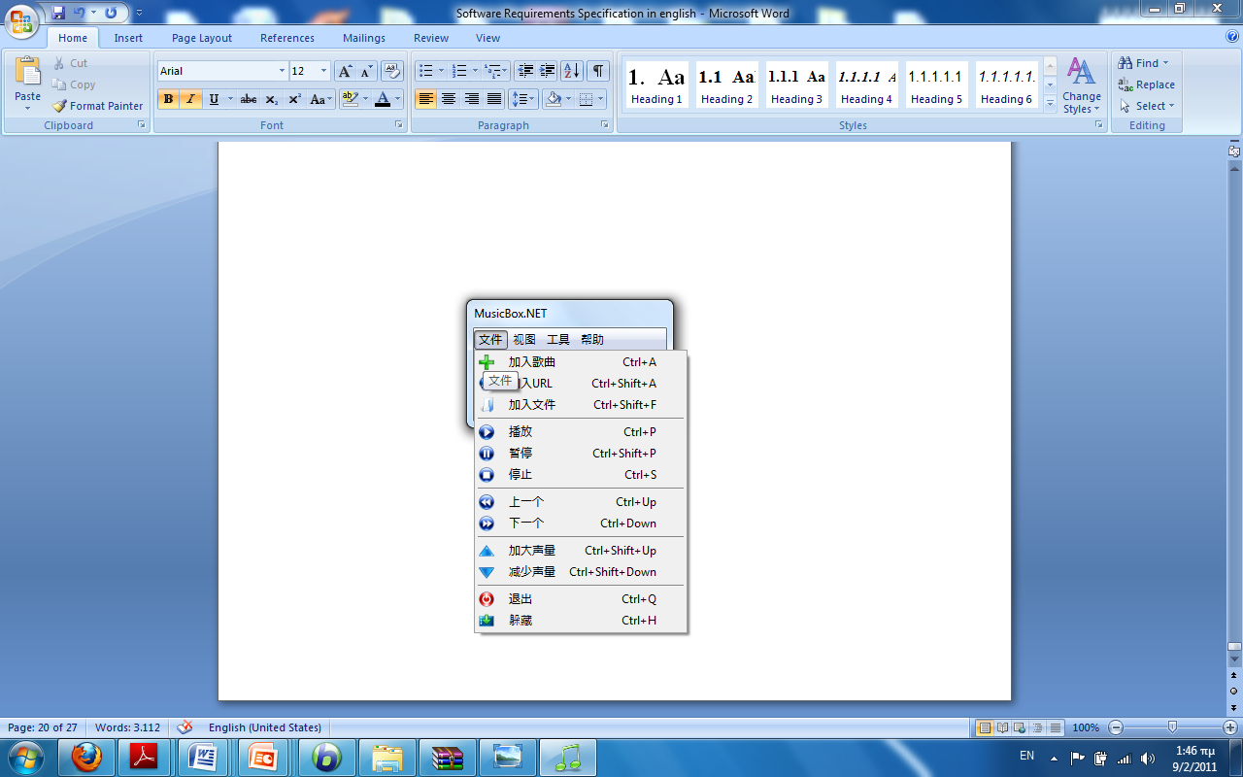
E.g. after Chinese installation:

Visualize Aero Ctrl+Alt+V
This choice is visualize aero!

In these websites is a demo video of the feature
- http://www.youtube.com/watch?v=Bts3uMi3vRA&feature=player_embedded#

- http://musicboxdotnet.blogspot.com/2010/09/aero-visualization.html

Users can also activate this choice if they key in Ctrl+Alt+V on the main window.

Mixer Ctrl+M
Users can play around with the mixer by scrolling the scrollbars. It is categorized as 8 KHz, 128 KHz, Dry, DX8 effects, vocals. Users can also activate this choice if they key in Ctrl+M on the main window.
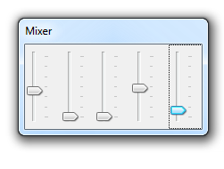

Tags Editor Ctrl+E
When users have done editing the tags, they can save it by click on Save or by pressing CTRL+S on the tags editor window. Users can activate the Tags Editor if they key in Ctrl+E on the main window.
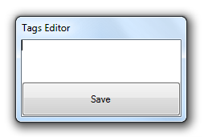

Associate File Types
This choice associates all supported file formats to application via registry.

Unassociate File Types
This choice unassociates all supported file formats to application via registry.

Console Ctrl+C
With this operation appears a Console application which acts like a Windows' Command Prompt (CMD) for MusicBox.NET. Users can also activate this if they key in Ctrl+C on the main window.
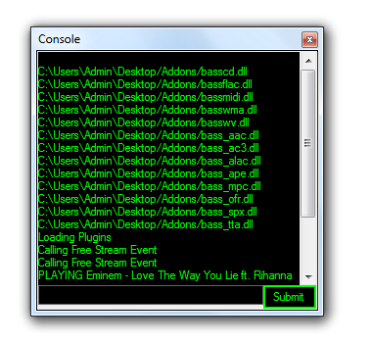

3.4 Help Menu

The fourth choice which is Help includes the following:
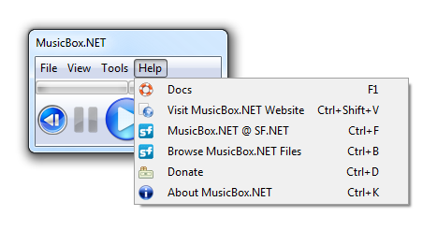

Docs F1
With this operation opens:
http://musicboxdotnet.sourceforge.net/doc/ari.html
Which is a help document designed to be plain and simple to understand.
Users can also activate this choice if they key in F1 on the main window.

Visit MusicBox.Net Website Ctrl+Shift+V
This operation opens the website:
http://www.musicboxdotnet.sourceforge.net
Users can also activate this choice if they key in Ctrl+Shift+V on the main window.

MusicBox.Net @ SF.NET Ctrl+F:
This operation opens the Project’s Home:
http://www.sourceforge.net/projects/musicboxdotnet
Users can also activate this choice if they key in CTRL+F on the main window.

Browse MusicBox.Net files Ctrl+B
With this operation it opens:
http://sourceforge.net/projects/musicboxdotnet/files/ρρ
Users can also activate this choice if they key in CTRL+B on the main window.

Donate Ctrl+D
This operation opens:
http://musicboxdotnet.blogspot.com/p/donate.html
Users can also activate this choice if they key in CTRL+D on the main window.

About MusicBox.NET Ctrl+K
With this choice all the information about MusicBox.Net (MusicBox.Net, Credits, ChangeLog and Contact) appears in a box as below. Users can also activate this choice if they key in CTRL+K on the main window.

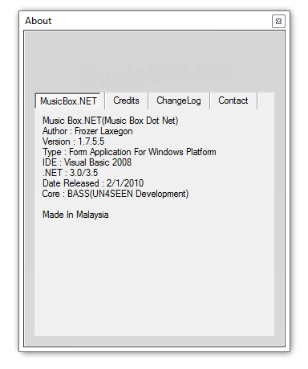

3.5 Buttons

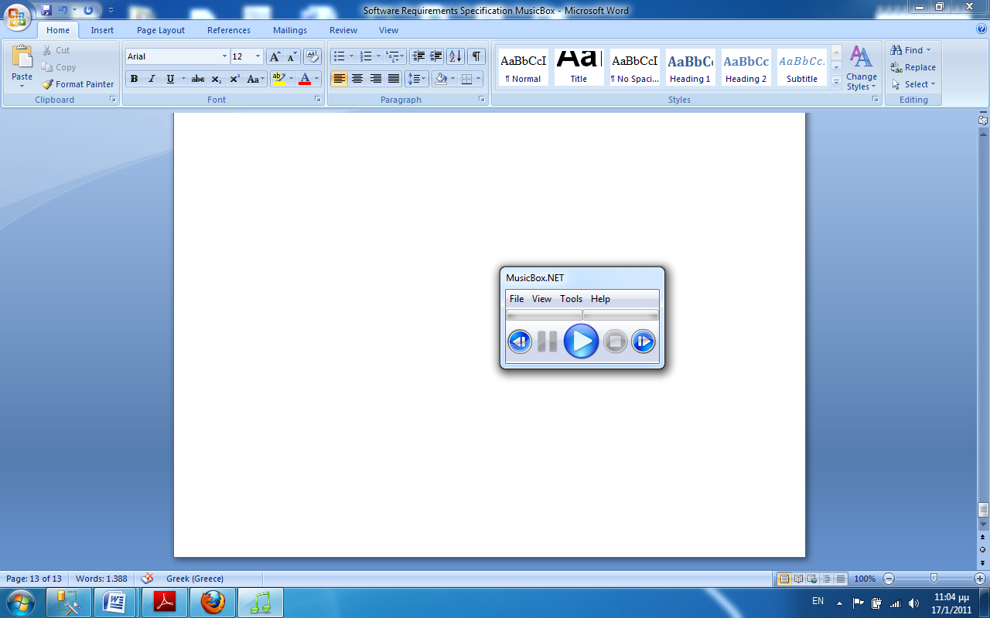
Previous Button
With this button the previous song on playlist is chosen automatically and starts play.

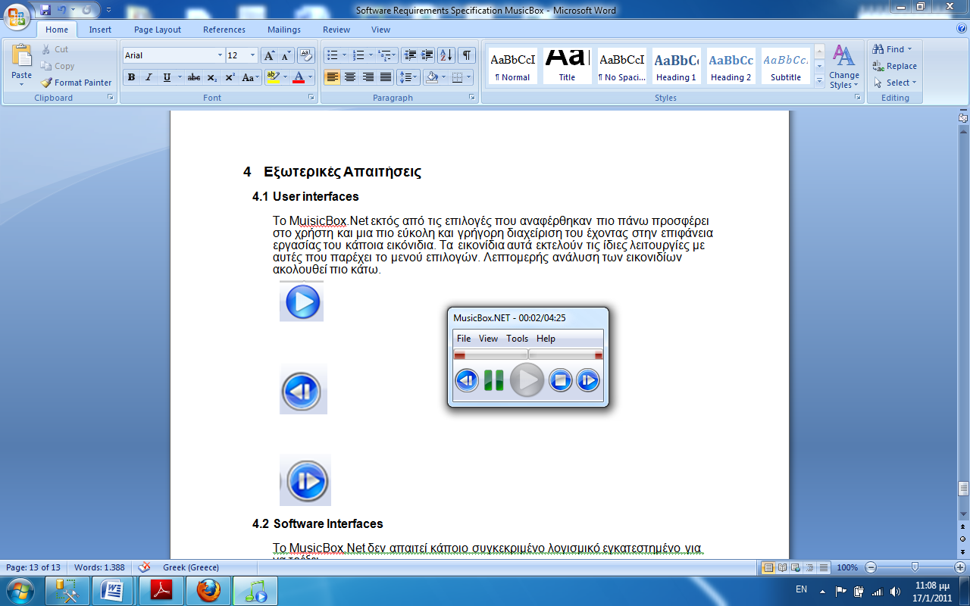
Pause Button
This button temporary stops the current playing song and if user chooses the Play (see above) then it can continue from the same point.

Play Button
With this button you can play and resume the paused song that the user has chosen.

Stops Button
With this button current song stops play and reset its position.

Next Button
With this button the next song on playlist is chosen automatically and starts play.

3.6 Keyboard
Add Media To Playlist CTRL + A
Add From URL CTRL + SHIFT + A
Add From Folder CTRL + SHIFT + F
Play CTRL + P
Pause CTRL + SHIFT + P
Stop CTRL + S
Previous On Playlist CTRL + UP
Next On Playlist CTRL + DOWN
Volume Up CTRL + SHIFT + UP
Volume Down CTRL + SHIFT + DOWN
Exit CTRL + Q
Hide To Tray CTRL + H
Visualization CTRL + V
Playlist CTRL + ALT + P
Music Information CTRL + I
Lyrics CTRL + L
Tracker CTRL + T
Repeat CTRL + R
Repeat Playlist CTRL + ALT + R
Save Playlist As CTRL + SHIFT + S
Load Saved Playlist CTRL + ALT + L
Wave Graph CTRL + W
Languages CTRL + SHIFT + L
Visualizes Aero CTRL + ALT + V
Mixer CTRL + M
Tags Editor CTRL + E
Console CTRL + C
Docs F1
Visit Website CTRL + SHIFT + V
MusicBox.NET @ Sourceforge.NET CTRL + F
Browse MusicBox.NET Files CTRL + B
Donate CTRL + D
About CTRL + K
System-wide / Global hotkeys
Toggle Play / Pause ALT + UP
Stop ALT + DOWN
Previous ALT + LEFT
Next ALT + RIGHT
Toggle Aero Visualizations ALT + V
4. External Interface Requirements
User interfaces
- Title Bar – shows song length and position.
- Menu Bar - contains "File", "View", "Tools" and "Help".
- Left Progress Bar - shows volume on the left speaker.
- Right Progress Bar - shows the volume on the right speaker.
- Previous Button - switch to the previous song in the playlist
- Pause Button - temporary stops the current playing audio.
- Play Button - plays and resume the paused audio.
- Stops Button - stops the current playing audio and reset its position.
- Next Button - switch to the next song in the playlist.
- File - contains important functions such as "Add", "Add From URL", etc.
- View - contains optional functions such as "Visualizations", "Repeat", etc.
- Tools - contains editing tools such as "Tags Editor", "Playlist Tool", "Console",
Etc.
- Help - contains support and information about the program.
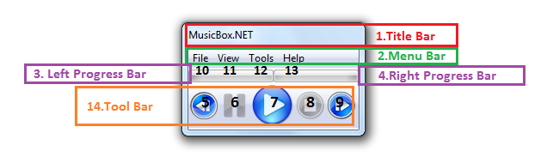
- Tool Bar - contains playing functions such as "Play", "Pause", "Stop", etc.
4.2 Hardware Interfaces

MusicBox.Net does not require additional material to run. The only peripheral equipment is the keyboard and the mouse.

  - Software Interfaces
These are the minimum requirements that are needed to run and built MusicBox.NET
- OS : Windows XP with Service Pack 3 installed.
- .NET Framework : .NET Framework 3.5.
- DirectX : DirectX 3 for audio.
- RAM : 512MB.
- Disk Space : 10MB free space.

4.4 Communications Interfaces
None

5. Other Nonfunctional Requirements

5.1 Performance Requirements
MusicBox.Net requires a small amount of disk space for installation-10MB.It is characterized by fast loading and executing times. It‘s not a heavy program and it can works while other programs are running.

5.2 Safety Requirements
There are no specific safety requirements as MusicBox.Net cannot make user’s computer malfunction in any way.

5.3 Security Requirements
This project is licensed under the GNU General Public License. MusicBox.Net is an Open Source project and free for use. As it has its license agreement, anyone can use it, distribute it, view and change its source code.
http://www.gnu.org/licenses/licenses.html

5.4 Software Quality Attributes
MusicBox.Net is easy to use because is a small program. Users can easily learn to use it. The software’s interface is quite friendly, simple, easily understood, it works fast and is organized. MusicBox.Net is a very fast and efficient program and users can easily change its options to satisfy their needs.

